**Knife Skills**

*Demonstration Directions:*

1. Research each knife skill and complete the
2. Take notes and write a description of each knife skill below.
3. Draw a diagram of the different knife parts on the back of your paper.

|  |  |  |
| --- | --- | --- |
| **Knife Skill** | **Description** | **Picture** |
| **Julienne** |  |  |
| **Brunoise** |  |  |
| **Chiffonade** |  |  |
| **Mince** |  |  |
| **Dice** |  |  |
| **Chop** |  |  |
| **Slice** |  |  |

*“Parts of the Knife” Directions:*

1. Label all of the following parts.

- Point - Tip - Back - Bolster or Shank - Rivets

- Blade - Heel - Handle - Cutting Edge - Tang

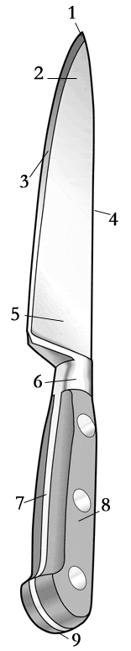

**10**

*“Types of Knives” Directions:*

1. On the chart below, draw a picture of the following types of knives and list a brief description.

|  |  |  |
| --- | --- | --- |
| **Type of Knife** | **Diagram** | **Description** |
| **Chef’s Knife** |  |  |
| **Slicer** |  |  |
| **Serrated Slicer** |  |  |
| **Boning Knife** |  |  |
| **Paring Knife** |  |  |
| **Tournee Knife** |  |  |
| **Fillet Knife** |  |  |
| **Butcher Knife** |  |  |